 | Ridge Circle Paw Laws | 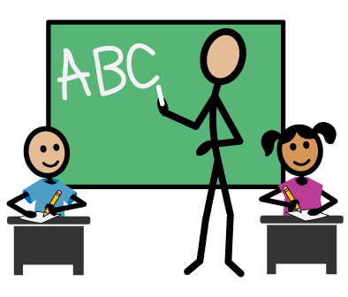  Instrucción | 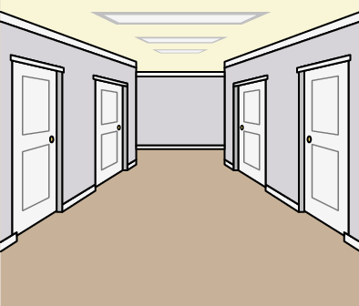  Pasillos |  | 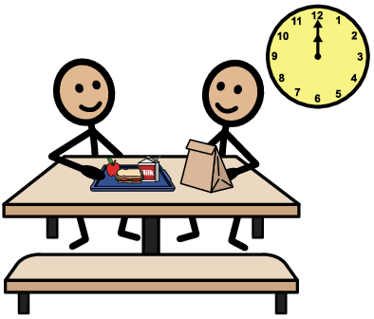  Cafetería |  | 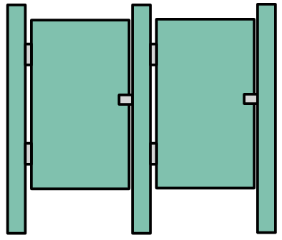  Baños |  | 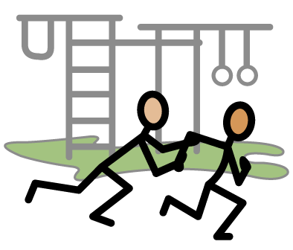  Recreo |  | 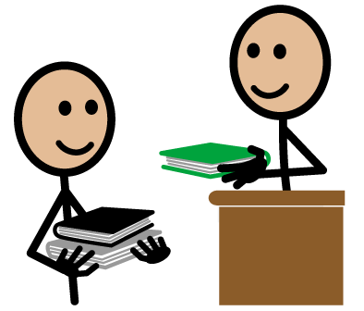  Biblioteca
 | Sé respetuoso  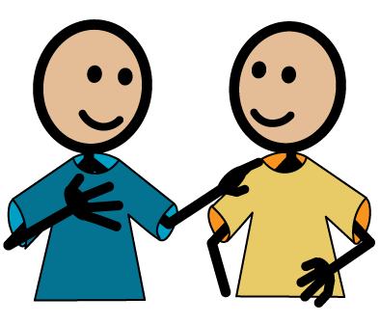 | Sigue las indicaciones y reglas del salón apropiadamente | Respeta el espacio de los demás |  | Sigue las indicaciones de los adultos |  | Espera en silencio en los pasillos |  | Sigue las indicaciones |  | Habla en voz baja
 |  | Espera tu turno y levanta la mano | Estate callado |  | Usa lenguaje apropiado |  | Espera tu turno |  | Usa palabras cordiales |  | Cuida los libros de la biblioteca
 |  | Escucha a los demás |  |  | Come tu propio almuerzo |  | Respeta la privacidad de los demás |  | Pide permiso para dejar el área designada |  | Sé correcto y educado
 |  | Usa palabras cordiales |  |  | No grites |  | Mantén las paredes y puertas sin escrituras |  | Usa lenguaje apropiada |  | Espera pacientemente tu turno para devolver y sacar libros
 | Sé responsable  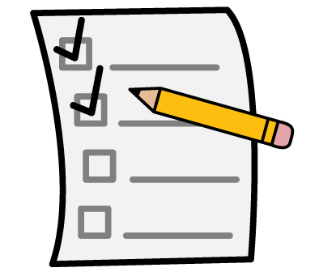 | Haz tu tarea | Camina en una línea recta |  | Limpia el área donde comiste antes de irte |  | Bájale al baño |  | Comparte los juegos |  | Coloca las sillas al irte
 |  | Cuida los materiales y los muebles | Mantente en tu lugar en la línea |  | Si necesita salir pide permiso |  | Lávate las manos con agua y jabón y sécatelas con una toalla de papel |  | Espera tu turno con paciencia |  | Devuelve los libros a tiempo
 |  | Sé honesto |  |  | Recicla |  | Usa la cantidad de papel apropiada |  | Demuestra buena conducta deportiva |  | Escoge libros apropiados
 |  | Pide ayuda cuando la necesites |  |  |  |  | Tira la basura |  |  |  | Trabaja sin distraerte
 | Sé cuidadoso  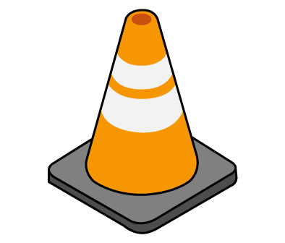 | Camina | Camina |  | Camina |  | Camina |  | Mantén tus pies, manos, y objetos quietos |  | Camina
 |  | Mantén tus pies, manos, y objetos quietos | Mantén tus pies, manos, y objetos quietos |  | Mantén tus pies, manos, y objetos quietos |  | Mantén tus pies, manos, y objetos quietos |  | Usa los juegos de una manera apropiada y segura |  | Mantén tus pies, manos, y objetos quietos
 |  | Ayuda a los demás |  |  | Notifica cualquier accidente al personal |  | Mantén tus pies en el suelo |  | Si alguien está lastimado notifica inmediatamente a tu supervisora
 |  | Usa los juegos y materiales de una manera apropiada y segura |  |  | No compartas tu comida |  | Notifica cualquier problema a tu maestro/a
 |  | Trae a la escuela solo materiales apropiados
Ridge Circle Paw Laws |  | Antes de la escuela  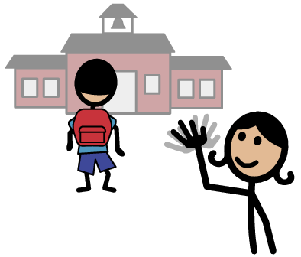 |  | Después de la escuela  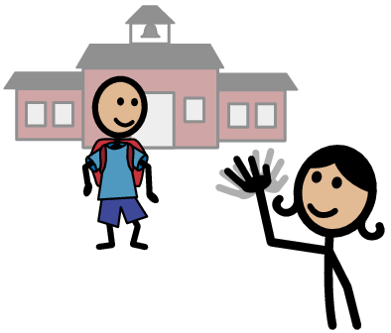 |  | Paseos  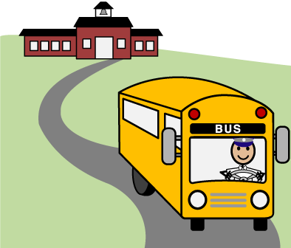 |  | Asambleas  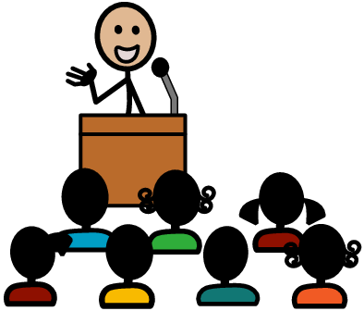 |  | Sala de computadoras  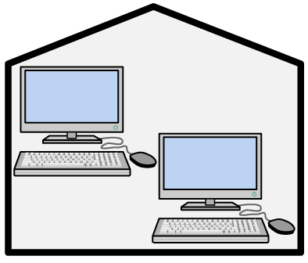
Sé respetuoso |  | Escucha a los supervisores, maestros, y patrulleros |  | Escucha a los supervisores, maestros, y patrulleros |  | Escucha al conductor del autobús y otros adultos |  | Estate callado |  | Usa los materiales adecuadamente
 |  | Espera pacientemente |  | Espera pacientemente |  | Habla en voz baja |  | Escucha |  | Deja la pantalla del inicio tal como está
 |  | Usa palabras cordiales |  | Usa palabras cordiales |  | Usa palabras cordiales |  | Pon atención |  | Sigue las indicaciones
 |  |  |  |  |  |  |  | Mira a la persona que habla
Sé responsable |  | Quédate en tu zona designada |  | Quédate con tu clase a la hora de salir |  | Sigue las indicaciones |  | Siéntate en tus pompis |  | Siéntate enfrente de tu computadora asignada
 |  | Notifica cualquier problema al maestro o supervisor |  |  |  | Quédate con tu grupo |  | Levanta la mano para participar |  | Habla en voz baja
 |  | Entra a la escuela en silencio |  |  |  |  |  | Siéntate con tu clase |  | Cierra tu sesión antes de irte
Sé cuidadoso |  | Camina |  | Camina |  | Siéntate adecuadamente |  | Camina |  | Mantén tus pies, manos, y objetos quietos
 |  | Mantén tus pies, manos, y objetos quietos |  | Mantén tus pies, manos, y objetos quietos |  | Mantén tus pies, manos, y objetos quietos |  | Mantén tus pies, manos, y objetos quietos |  | Permanece en tu asiento
 |  | No montes tu bicicleta en la zona escolar |  |  |  | Mantén el cuerpo y los objetos dentro del autobús

Ridge Circle Paw Laws | Instruction |  | Hallways |  | Cafeteria |  | Restroom |  | Recess |  | Library
Be Respectful | Follow directions and classroom rules appropriately |  | Respect others space |  | Follow adult supervision |  | Wait quietly in the hallway |  | Follow directions |  | Use appropriate tone and voice levels
 | Wait your turn and raise your hand |  | Be quiet |  | Use appropriate language |  | Wait your turn |  | Use kind words |  | Take care of library materials
 | Listen to others |  |  |  | Eat your own lunch |  | Give others privacy |  | Ask permission to leave designated area |  | Be polite and courteous
 | Use kind words |  |  |  | Use inside voices |  | Keep walls and doors without writing |  | Use appropriate language |  | Wait your turn to return or checkout materials
Be Responsible | Complete your schoolwork |  | Walk in a straight line |  | Clean up eating area before leaving cafeteria |  | Flush |  | Share equipment |  | Push in chairs when leaving
 | Care for furniture and materials |  | Stay in your spot in line |  | Ask permission to leave |  | Wash hands with soap and water, dry with paper towel |  | Patiently wait your turn |  | Return books when due
 | Be honest |  |  |  | Recycle |  | Use appropriate amount of paper |  | Show good sportsmanship |  | Pick appropriate books
 | Ask for help when needed |  |  |  |  |  | Throw away trash |  |  |  | Stay on task
Be Safe | Help others |  | Walk |  | Walk |  | Walk |  | Keep hands, feet, and objects to yourself |  | Walk
 | Walk |  | Keep hands, feet, and objects to yourself |  | Keep hands, feet, and objects to yourself |  | Keep hands, feet, and objects to yourself |  | Use equipment and materials in a safe, appropriate manner |  | Keep hands, feet, and objects to yourself
 | Keep hands, feet, and objects to yourself |  | Stay to the right |  | Report accidents immediately to staff |  | Keep your feet on the ground |  | Tell a supervisor immediately if someone is hurt
 | Use equipment and materials safely |  |  |  | Wait your turn |  | Report any problems to your teacher
 | Bring only school appropriate materials |  |  |  | Do not share your food
Ridge Circle Paw Laws |  | Before School |  | After School |  | Field Trips |  | Assemblies |  | Computer Lab
Be Respectful |  | Listen to supervisors, teachers, and patrols |  | Listen to supervisors, teachers, and patrols |  | Listen to bus driver and other adults |  | Be quiet |  | Use materials appropriately
 |  | Wait patiently |  | Wait patiently |  | Use a quiet voice |  | Listen |  | Leave the computer settings the same
 |  | Use kind words |  | Use kind words |  | Use kind words |  | Pay attention |  | Follow directions
 |  |  |  |  |  |  |  | Eyes on the speaker
Be Responsible |  | Stay in designated area |  | Stay with your class when exiting |  | Follow directions |  | Sit on your bottom |  | Sit at your designated computer
 |  | Report problems to supervisor or teacher |  |  |  | Stay with your group |  | Raise your hand to participate |  | Use a quiet voice
 |  | Enter the building quietly |  |  |  |  |  | Sit with your class |  | Logoff computer before leaving
Be Safe |  | Walk |  | Walk |  | Stay seated in an appropriate manner |  | Walk |  | Keep hands, feet, and objects to yourself
 |  | Keep hands, feet, and objects to yourself |  | Keep hands, feet, and objects to yourself |  | Keep hands, feet, and objects to yourself |  | Keep hands, feet, and objects to yourself |  | Stay in your seat
 |  | Walk your bike on school property |  |  |  | Keep body and objects inside the bus

